Acceptance Testing
UAT Execution & Report Submission
Date | 08 October 2026
Team ID | 9100Smartgirls
Project Name | Streamlining IT Procurement: Automating Standard Laptop Orders with Flow Designer
Maximum Marks | 4 Marks

1. Purpose of Document
The purpose of this document is to briefly explain the test coverage and open issues of the Streamlining IT Procurement: Automating Standard Laptop Orders with Flow Designer project at the time of the release to User Acceptance Testing (UAT).
2. Defect Analysis
This report shows the number of resolved or closed bugs at each severity level, and how they were resolved
Resolution | Severity 1 | Severity 2 | Severity 3 | Severity 4 | Subtotal
By Design | 0 | 0 | 0 | 1 | 1
Duplicate | 0 | 0 | 0 | 0 | 0
External | 0 | 0 | 0 | 0 | 0
Fixed | 0 | 0 | 0 | 0 | 0
Not Reproduced | 0 | 0 | 0 | 0 | 0
Skipped | 0 | 0 | 0 | 0 | 0
Won't Fix | 0 | 0 | 0 | 0 | 0
Totals | 0 | 0 | 0 | 1 | 1

3. Test Case Analysis
This report shows the number of test cases that have passed, failed, and untested
Section | Total Cases | Not Tested | Fail | Pass
Service Catalog Ordering | 2 | 0 | 0 | 2
Request Approval | 2 | 0 | 0 | 2
Flow Execution and Task Creation | 2 | 0 | 0 | 2
Catalog Task Details | 1 | 0 | 1 | 0
Totals | 7 | 0 | 1 | 6

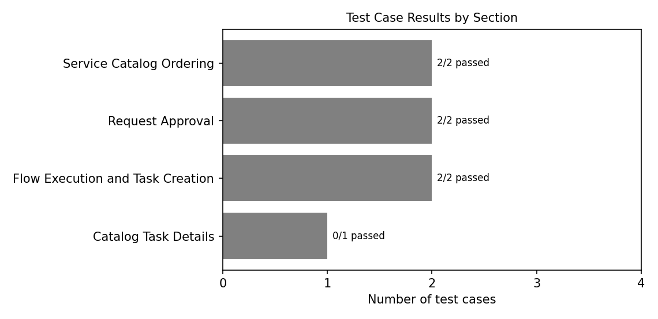
Note: One further defect, BG-001 (Severity 4, catalog task Short Description capitalised as "Configured"), is open and is not counted in the resolved or closed table above. Test case numbering follows the User Acceptance Testing document (TC-001 to TC-007), and the Functional & Performance Testing document refers to the same test cases.

